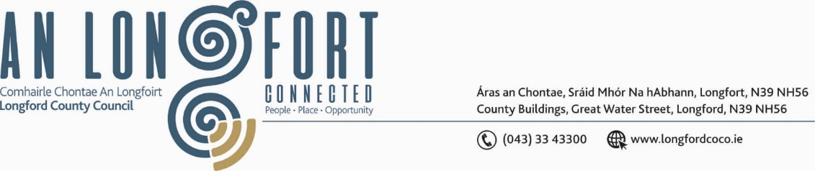

BALLYMAHON MUNICIPAL DISTRICT

Please note meeting will be held in Ballymahon Library.

30 November 2023

To: Each Member of Ballymahon Municipal District.

Dear Member,

You are requested to attend a Meeting of Ballymahon Municipal District to be held
in Ballymahon Library on Thursday 7 December 2023 at 4pm to transact business, as set out on the agenda hereunder.

Yours sincerely,

_______________
Claire McNabola,
Meetings Administrator.

AGENDA

Prayer before meeting.

- Confirmation of Minutes
- Ballymahon Municipal District Meeting held on the 28 September 2023 – enclosed.
- Ballymahon Municipal District Meeting held on the 26 October 2023 – enclosed.
- Ballymahon Municipal District Committee Meeting held on the 26 October 2023 – enclosed.

2. Matters arising from Minutes

3. Declaration of Interest by Members

4. Management Report – enclosed

5. Community Climate Action Fund

6. Community Grant Support Scheme

7. School Traffic Warden – Lanesborough National School

8. Proposed dates for 2024 MD meetings

9. Notices of Motions, submitted by Councillors, as listed hereunder –

Councillor Paul Ross
- That a footpath/cyclepath be constructed from the Silver Birches estate to Stonepark School to link these houses and creche to the School.

- That an update be provided to the council on the installation of CCTV in Edgeworthstown and Ballymahon town and when the expected rollout of these schemes will commence.

- That a new walking/cycle looped route be created in Edgeworthstown on the old Dublin Road by C&D back round to the N4

Councillor Gerard Farrell
- That Longford County Council seek funding to fully revamp Lanesboro children's playground.

- That Longford County Council replace the footpaths at Knock, Lanesboro.

- That Longford County Council provide new compactor bins for recreational areas in Lanesboro.

Councillor Mark Casey
- That a full review be carried out on the street lighting in Lanesboro, especially the Church Road, The Green, Knock and at the start of the Rathcline road.

- That the Footpaths in Knock, Lanesboro be replaced/repaired.

- That Longford County Council place a new Bottle Bank in Formoyle (Lisnacusha).

